**LAPORAN PRAKTIKUM**

**MODUL 1: REVIEW MOBILE DASAR**



**Oleh:**

Dinarpratnya Ningrum

1641720102

**PRUGRAM STUDI D4 TEKNIK INFORMATIKA**

**JURUSAN TEKNOLOGI INFORMASI**

**POLITEKNIK NEGERI MALANG**

**2019**

## DAFTAR ISI

DAFTAR ISI 2

DAFTAR GAMBAR 3

DAFTAR SOURCECODE 4

1. LATAR BELAKANG 5

2. TUJUAN 5

3. PERANCANGAN 5

4. IMPLEMENTASI 6

4.1. IMPLEMENTASI SOURCECODE 6

4.2. IMPLEMENTASI TAMPILAN 7

5. DAFTAR PUSTAKA 8

## DAFTAR GAMBAR

Gambar 4.1 Screenshot Activity 1. 7

## DAFTAR SOURCECODE

Sorcecode 4.1 Sourcecode Activity 1. 6

## LATAR BELAKANG

Tuliskan apa manfaat dan kegunaan dari *Layout, Recycle View, Shared Preferences, Intent, SQLite, Retrofit.*

* **Manfaat Layout**

Layout merupakan suatu tampilan tata letak di Android untuk mengatur penempatan teks, gambar, ataupun komponen lainnya sehingga tampilan pada aplikasi yang dibuat terlihat rapih dan nyaman untuk dilihat oleh pengguna

(<https://www.codepolitan.com/mempelajari-layout-pada-android-studio>)

* **Manfaat Recycle View**

Suatu grup Tampilan untuk kontainer yang bisa digulir. Secara umum, RecyclerView menyimpan sebanyak mungkin tampilan item yang muat di layar, plus sedikit tambahan pada setiap akhir daftar untuk memastikan pengguliran berjalan cepat dan lancar.

(<https://google-developer-training.github.io/android-developer-fundamentals-course-concepts/idn/Unit%202/44_c_recyclerview.html#recyclerview>)

* **Maanfaat *Shared Preferences***

Mencegah aplikasi logout setelah kita login, dan kita tidak perlu melakukan login berulang kali setiap membuka aplikasinya

**(**<https://medium.com/dot-lab/tutorial-penggunaan-shared-preferences-pada-android-eddc300d7509>)

* **Manfaat *Intent***

Sebuah kelas dalam programming Android yang berfungsi untuk perpindahan halaman.

(<https://www.codepolitan.com/belajar-menggunakan-intent-sebuah-jembatan-interaksi-antar-komponen-599a5576271ef>)

* **Manfaat *SQLite***

Media penyimpanan utama untuk data aplikasi atau pengguna, atau juga bisa menggunakannya untuk proses caching serta menyediakan data yang diambil dari cloud.

(<https://medium.com/easyread/konsep-dasar-database-sqlite-pada-android-e9445558f494>)

* **Manfaat *Retrofit***

Library Rest Client untuk android dan java dari [squareup](https://square.github.io/retrofit/)..

(<https://www.codepolitan.com/rest-api-client-sederhana-dengan-retrofit-pada-android-studio-58986d62c46ae>)

## TUJUAN

* Agar kembali paham (ingat) dengan materi android sebelum diajarkan matri yang lebih rumit lagi
* Agar siap menerima materi selanjutnya

## PERANCANGAN

Gambarkan *mock-up* ketiga *activity* yang ditugaskan menggunakan *tools* seperti Mockplus, UI Design atau yang lainnya..

## IMPLEMENTASI

### IMPLEMENTASI SOURCECODE

|  |
| --- |
| <?xml version="1.0" encoding="utf-8"?> <LinearLayout  xmlns:android="http://schemas.android.com/apk/res/android"  xmlns:app="http://schemas.android.com/apk/res-auto"  android:layout_width="match_parent"  android:layout_height="match_parent"  android:layout_gravity="center"  android:orientation="vertical"  android:weightSum="3"  android:background="#244282">   <LinearLayout  android:layout_width="wrap_content"  android:layout_height="wrap_content"  android:layout_gravity="center|center"  android:layout_weight="1"  android:background="#244282">  </LinearLayout>  <LinearLayout  android:layout_width="wrap_content"  android:layout_height="wrap_content"  android:layout_gravity="center|center"  android:layout_weight="1"  android:orientation="horizontal">   <ImageView  android:id="@+id/logo"  android:layout_width="267dp"  android:layout_height="172dp"  android:layout_gravity="center"  app:srcCompat="@drawable/logo"  android:contentDescription="@string/todo" />  </LinearLayout>   <LinearLayout  android:layout_width="match_parent"  android:layout_height="wrap_content"  android:layout_weight="1"  android:orientation="vertical">  <Button  android:id="@+id/button1"  android:background="#fff"  android:layout_width="190dp"  android:layout_height="45dp"  android:layout_gravity="center_horizontal|center"  android:text="@string/get_started"  android:fontFamily="NovaMono for Powerline"  android:textSize="8pt"/>  </LinearLayout>  </LinearLayout> |

Sorcecode 4.1.1 Sourcecode XML Activity 1

|  |
| --- |
| package com.dinar.tugas1;  import androidx.appcompat.app.AppCompatActivity; import android.content.Intent; import android.os.Bundle; import android.view.View; import android.widget.Button;  public class MainActivity extends AppCompatActivity {   Button button1;  @Override  protected void onCreate(Bundle savedInstanceState) {  super.onCreate(savedInstanceState);  setContentView(R.layout.*activity_main*);  button1 = findViewById(R.id.*button1*);   button1.setOnClickListener(new View.*OnClickListener*() {  @Override  public void onClick(View view) {  Intent i = new Intent(getApplicationContext(), Main2Activity.class);  startActivity(i);  }  });  } } |

Sorcecode 4.1.2 Sourcecode Java Activity 1

|  |
| --- |
| <?xml version="1.0" encoding="utf-8"?> <RelativeLayout  xmlns:android="http://schemas.android.com/apk/res/android"  android:layout_width="match_parent"  android:layout_height="match_parent"  android:background="#fff" >   <TextView  android:id="@+id/textView"  android:layout_width="wrap_content"  android:layout_height="wrap_content"  android:layout_alignParentStart="true"  android:layout_alignParentTop="true"  android:layout_marginStart="30dp"  android:layout_marginTop="30dp"  android:fontFamily="sans-serif-condensed"  android:text="Biodata"  android:textSize="40dp" />   <TextView  android:id="@+id/textView2"  android:layout_width="wrap_content"  android:layout_height="wrap_content"  android:layout_below="@+id/textView"  android:layout_alignParentStart="true"  android:layout_marginStart="30dp"  android:layout_marginTop="50dp"  android:fontFamily="sans-serif-condensed"  android:text="Nim"  android:textSize="20dp"/>   <EditText  android:id="@+id/editText"  android:layout_width="wrap_content"  android:layout_height="wrap_content"  android:layout_below="@+id/textView2"  android:layout_alignParentStart="true"  android:layout_marginStart="30dp"  android:ems="16" />  <TextView  android:id="@+id/textView3"  android:layout_width="wrap_content"  android:layout_height="wrap_content"  android:layout_below="@+id/editText"  android:layout_alignParentStart="true"  android:layout_marginStart="30dp"  android:layout_marginTop="50dp"  android:fontFamily="sans-serif-condensed"  android:text="Nama"  android:textSize="20dp"/>   <EditText  android:id="@+id/editText1"  android:layout_width="wrap_content"  android:layout_height="wrap_content"  android:layout_below="@+id/textView3"  android:layout_alignParentStart="true"  android:layout_marginStart="30dp"  android:ems="16" />   <Button  android:id="@+id/submit"  android:layout_width="340dp"  android:layout_height="wrap_content"  android:layout_below="@+id/editText1"  android:layout_alignParentStart="true"  android:layout_alignParentEnd="true"  android:layout_marginStart="33dp"  android:layout_marginTop="30dp"  android:layout_marginEnd="40dp"  android:padding="16dp"  android:background="#ed5353"  android:text="ENTER"  android:textColor="#fff"  android:fontFamily="sans-serif-condensed"  android:textSize="8pt"/>   </RelativeLayout> |

Sorcecode 4.1.3 Sourcecode XML Activity 2

|  |
| --- |
| package com.dinar.tugas1;  import androidx.appcompat.app.AppCompatActivity;  import android.content.Intent; import android.os.Bundle; import android.view.View; import android.widget.Button; import android.widget.EditText;  public class Main2Activity extends AppCompatActivity {   Button submit;  EditText editText, editText1;   @Override  protected void onCreate(Bundle savedInstanceState) {  super.onCreate(savedInstanceState);  setContentView(R.layout.*activity_main2*);   editText = findViewById(R.id.*editText*);  editText1 = findViewById(R.id.*editText1*);  submit = findViewById(R.id.*submit*);   submit.setOnClickListener(new View.*OnClickListener*() {  @Override  public void onClick(View view) {   Intent intent = new Intent(getApplicationContext(), Main3Activity.class);  intent.putExtra("nama", editText1.getText().toString());  startActivity(intent);  }  });  } } |

Sorcecode 4.1.4 Sourcecode Java Activity 2

|  |
| --- |
| <?xml version="1.0" encoding="utf-8"?> <androidx.constraintlayout.widget.ConstraintLayout  xmlns:android="http://schemas.android.com/apk/res/android"  xmlns:app="http://schemas.android.com/apk/res-auto"  xmlns:tools="http://schemas.android.com/tools"  android:layout_width="match_parent"  android:layout_height="match_parent"  tools:context=".Main3Activity">   <TextView  android:id="@+id/textView4"  android:layout_width="wrap_content"  android:layout_height="wrap_content"  android:layout_marginStart="140dp"  android:layout_marginTop="112dp"  android:fontFamily="sans-serif-condensed"  android:text="Hai, "  android:textSize="12pt"  app:layout_constraintStart_toStartOf="parent"  app:layout_constraintTop_toTopOf="parent" />  <TextView  android:id="@+id/textView5"  android:layout_width="wrap_content"  android:layout_height="wrap_content"  android:layout_marginTop="112dp"  android:layout_toRightOf="@+id/textView4"  android:fontFamily="sans-serif-condensed"  android:text="Text"  android:textSize="12pt"  app:layout_constraintStart_toEndOf="@+id/textView4"  app:layout_constraintTop_toTopOf="parent" />   <Button  android:id="@+id/button"  android:layout_width="wrap_content"  android:layout_height="wrap_content"  android:text="BACK"  android:fontFamily="sans-serif-condensed"  android:textColor="#fff"  android:background="#ed5353"  app:layout_constraintBottom_toBottomOf="parent"  app:layout_constraintEnd_toEndOf="parent"  app:layout_constraintStart_toStartOf="parent"  app:layout_constraintTop_toBottomOf="@+id/textView4" /> </androidx.constraintlayout.widget.ConstraintLayout> |

Sorcecode 4.1.5 Sourcecode XML Activity 3

|  |
| --- |
| package com.dinar.tugas1;  import androidx.appcompat.app.AppCompatActivity;  import android.content.Intent; import android.os.Bundle; import android.view.View; import android.widget.Button; import android.widget.TextView;  public class Main3Activity extends AppCompatActivity {   Button button;  TextView textView4, textView5;  @Override  protected void onCreate(Bundle savedInstanceState) {  super.onCreate(savedInstanceState);  setContentView(R.layout.*activity_main3*);   Button button = findViewById(R.id.*button*);  TextView textView4 = findViewById(R.id.*textView4*);  TextView textView5 = findViewById(R.id.*textView5*);   if(getIntent().getExtras()!=null){  textView5.setText(getIntent().getStringExtra("nama"));  }  button.setOnClickListener(new View.*OnClickListener*() {  @Override  public void onClick(View view) {   Intent intent = new Intent(getApplicationContext(), Main2Activity.class);  startActivity(intent);  }  });  } } |

Sorcecode 4.1.6 Sourcecode Java Activity 3

### IMPLEMENTASI TAMPILAN

**

Gambar 4.2.1 Screenshot Activity 1

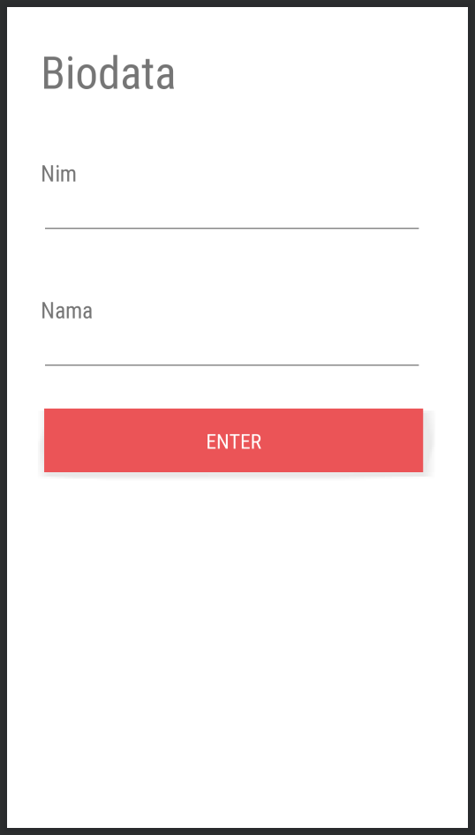

Gambar 4.2.2 Screenshot Activity 2

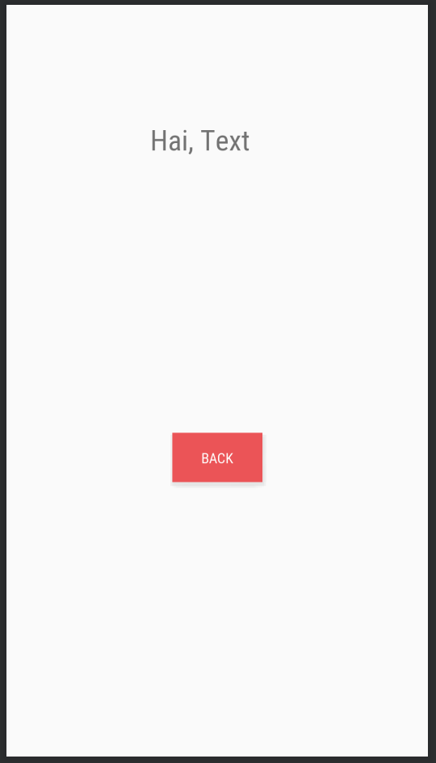

Gambar 4.2.3 Screenshot Activity 3

## DAFTAR PUSTAKA

* <https://www.codepolitan.com/mempelajari-layout-pada-android-studio>
* <https://google-developer-training.github.io/android-developer-fundamentals-course-concepts/idn/Unit%202/44_c_recyclerview.html#recyclerview>
* <https://medium.com/dot-lab/tutorial-penggunaan-shared-preferences-pada-android-eddc300d7509>
* <https://www.codepolitan.com/belajar-menggunakan-intent-sebuah-jembatan-interaksi-antar-komponen-599a5576271ef>
* <https://medium.com/easyread/konsep-dasar-database-sqlite-pada-android-e9445558f494>
* <https://www.codepolitan.com/rest-api-client-sederhana-dengan-retrofit-pada-android-studio-58986d62c46ae>